**Assignment -1**

|  |  |
| --- | --- |
| Assignment Date | 27 September 2022 |
| Student Name | KEERTHIRAJAN A |
| Student Roll Number | 922519205055 |
| Maximum Marks | 2 Marks |

**Question-1:**

To design a circuit using PIR sensor, Temperature sensor and Piezo alarm and to perform the following operations:

1. Alarm should sound in one manner if the temperature is above “60 C”.
2. Alarm should sound with another frequency if motion is detected using PIR sensor.

**Solution:**

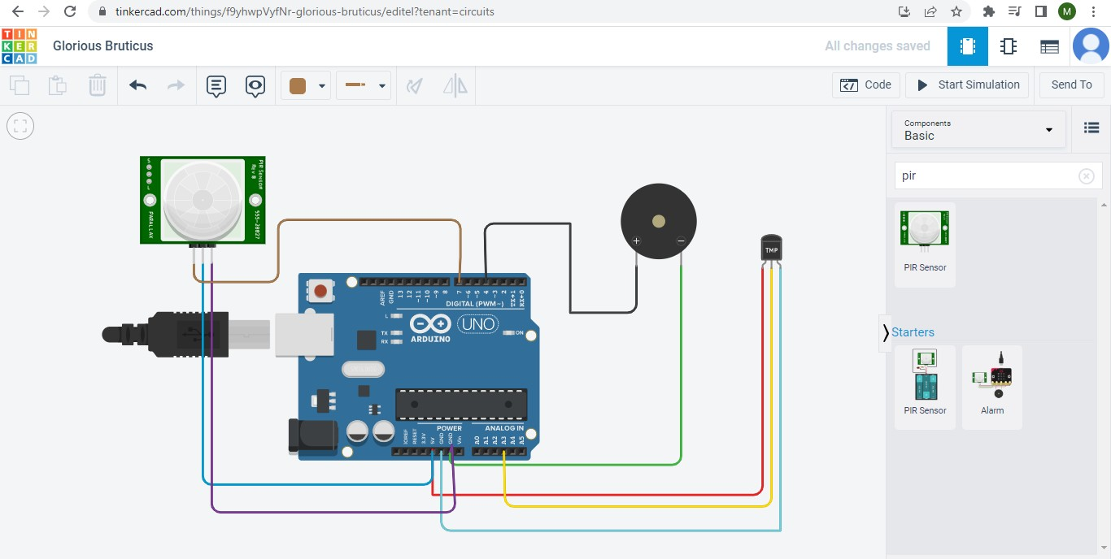

# Code

void setup()

{

Serial.begin(9600); pinMode(4,OUTPUT); pinMode(7,INPUT);

}

void loop()

{

int mov=digitalRead(7); double dt=analogRead(A3); double n=dt/1024;

double volt=n*5; double offset=volt-0.5;

double temp=offset*100; Serial.print("Temperature Detected: "); Serial.println(temp);

if(mov==0){

Serial.println("No Motion Detected");

}

if(mov==1){ Serial.println("Motion Detected"); tone(4,100,1000);

}

if(temp>60){ tone(4,400,1000);

}

}

# Output:

